Cuesta District Spring 2023 Camporee

Theme: Wild West

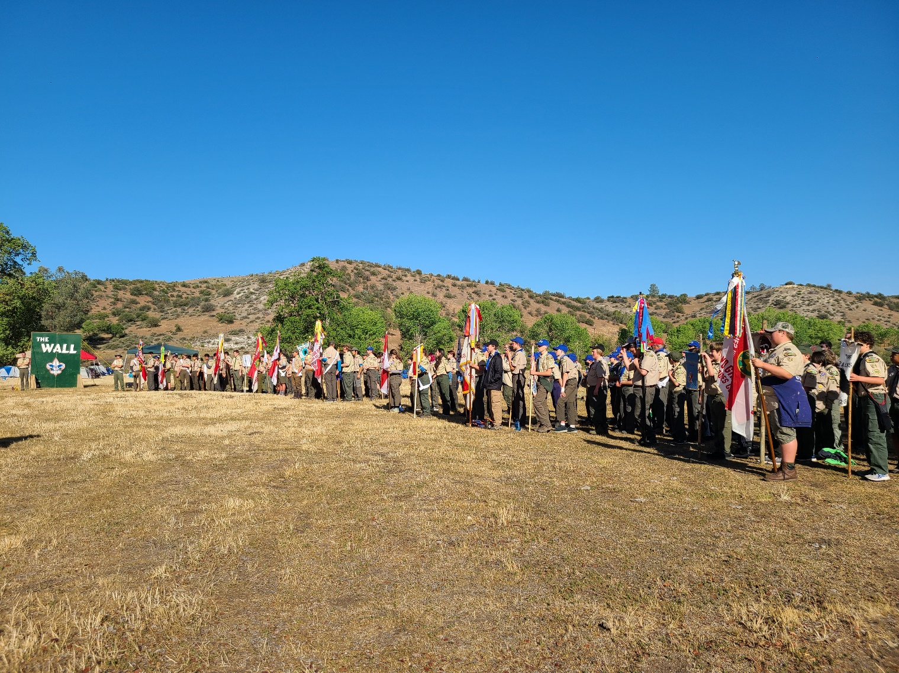
Map 3
Safety Information 4
Ticks: 4
Rattlesnakes: 5
Heat Exhaustion/Heat Stroke/ Sunburn: 6
Allergies: 7
Water: 7
Check-In & Uniform Inspection: 8
Event List & Scoring 8
Scoring and Time Limits 9
Events 9
Campfire Skit 10
Adult Dutch Oven Contest 11
2023 Camporee Campsite Inspections 12
Camporee Schedule 14
GENERAL INFORMATION 15

Map

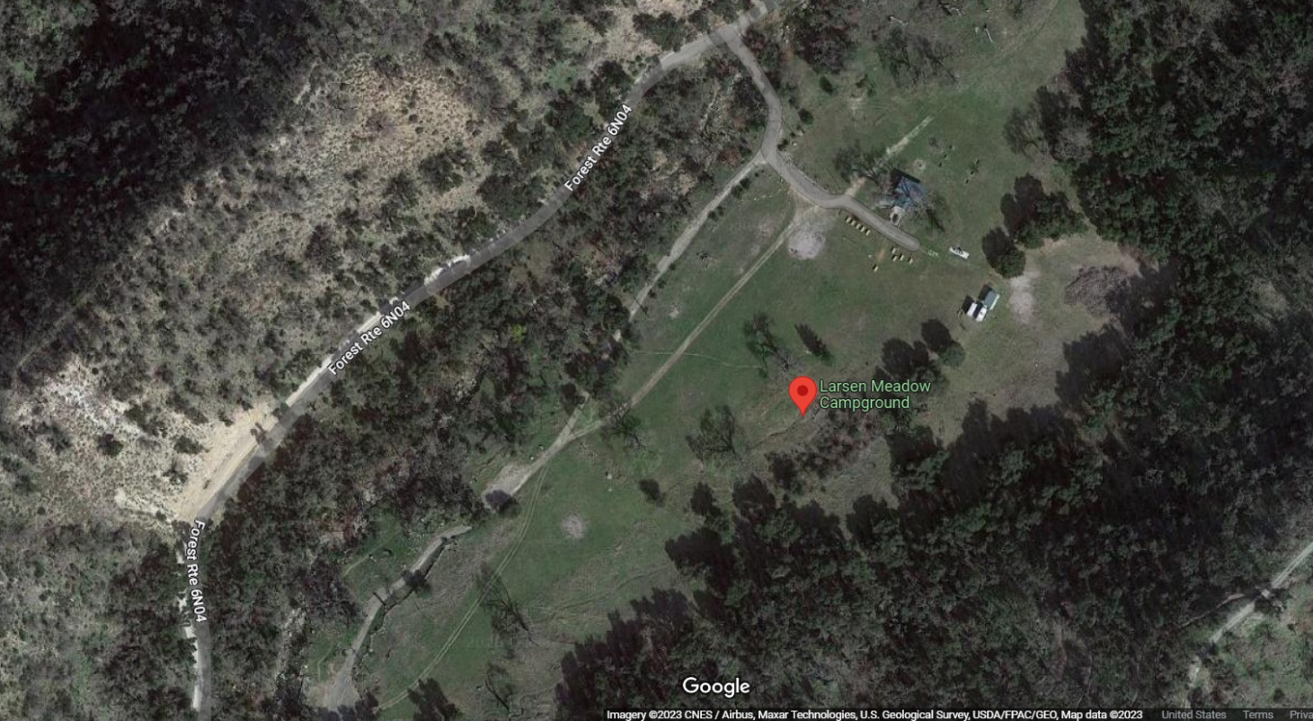

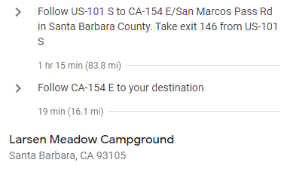

Safety Information
This is an official BSA event which means it is an ALL WEATHER EVENT. Please pack and plan accordingly.
It is important that we stay safe in the outdoors and being safe means knowing about the potential hazards that we might encounter at the Larsen Meadow. We have identified three key environmental hazards below: Ticks, Rattlesnakes, and Weather. Please review and make sure that your unit is prepared for each of these hazards.

Ticks:
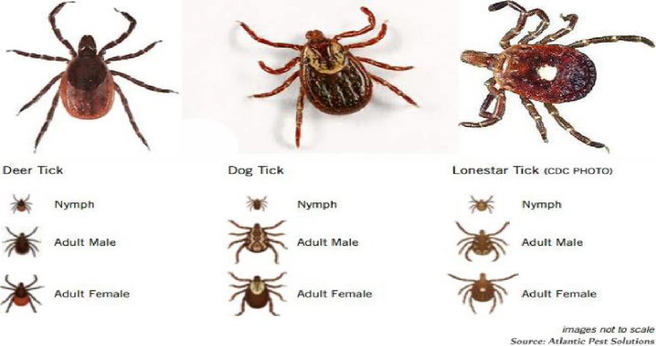
We will be in area that potentially could have ticks. Ticks are small, hard-shelled creatures that bury their heads in the skin. To remove a tick, (see first aid station) put on sterile gloves and use tweezers to grasp the tick as close to skin as possible. Gently pull until the tick comes loose.

DO NOT squeeze, twist, or jerk the tick. Doing so may cause the mouthparts to break off in the skin. Wash the wound with soap and water and apply antiseptic. Wash your hands after dealing with a tick. Ticks sometimes spread Lyme disease, Rocky Mountain spotted fever, and other serious illnesses.
If you develop a rash, bullseye circle around wound, or flulike symptoms or otherwise feel ill in the next days or weeks after being bitten by a tick, consult a physician.
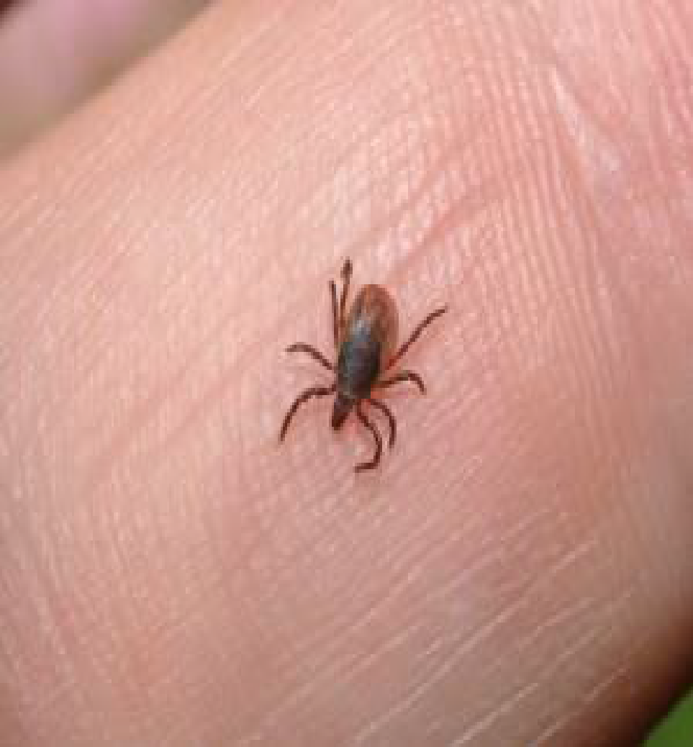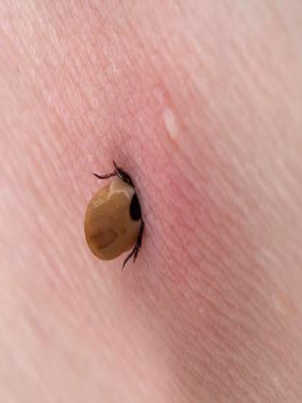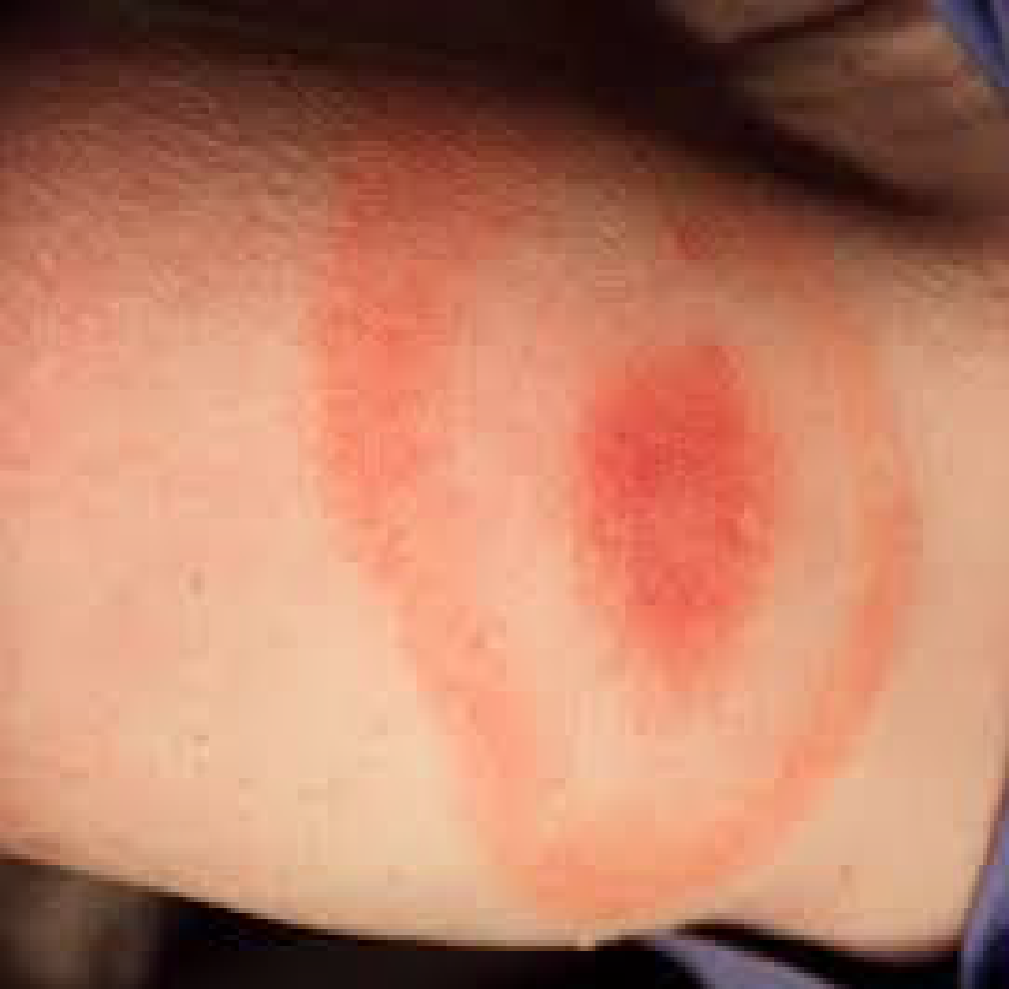

Rattlesnakes:
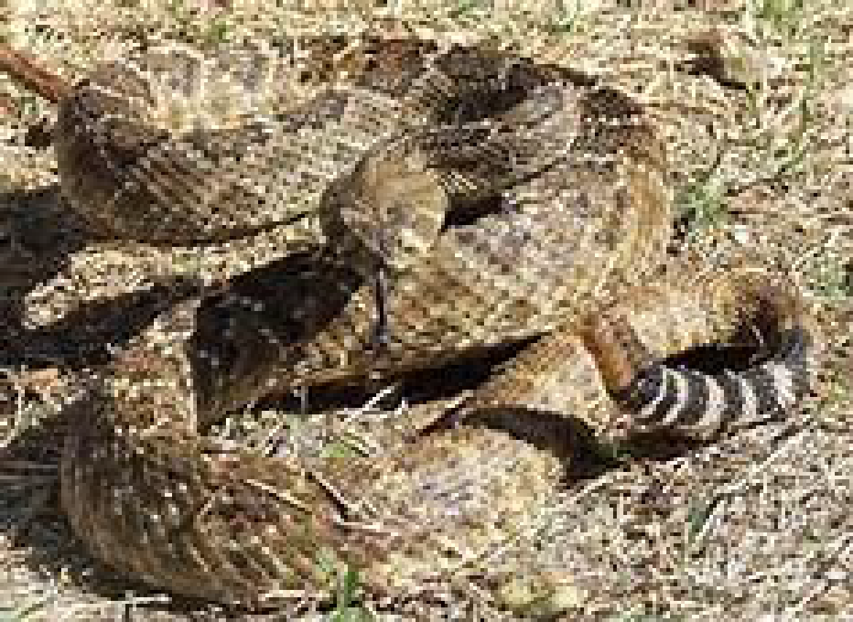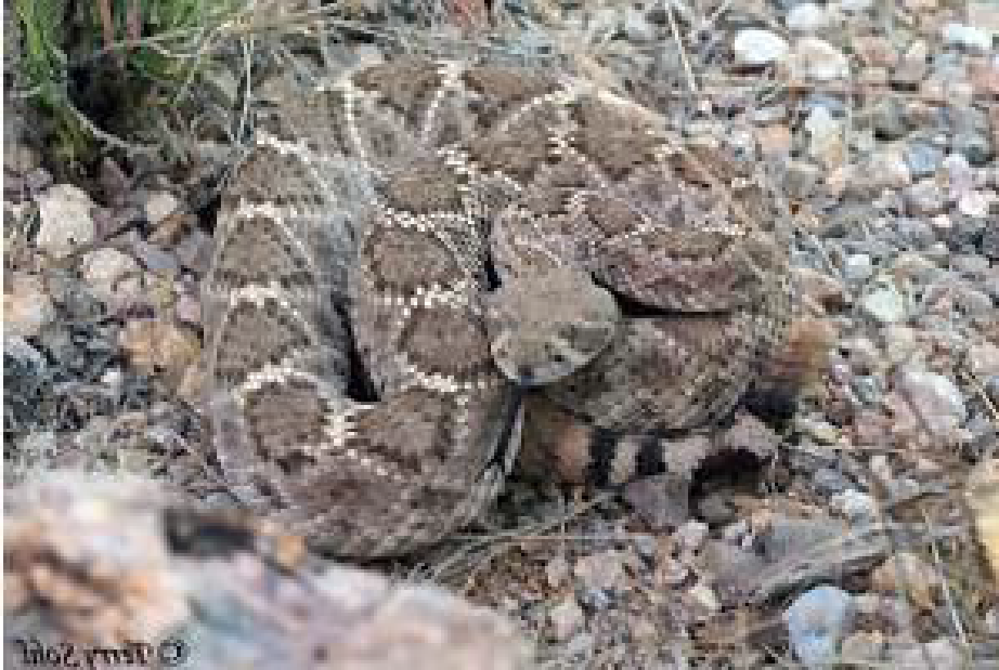
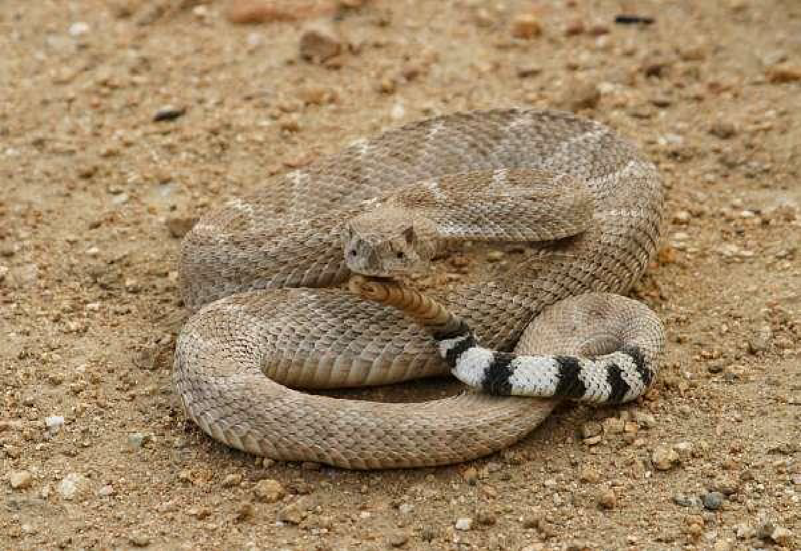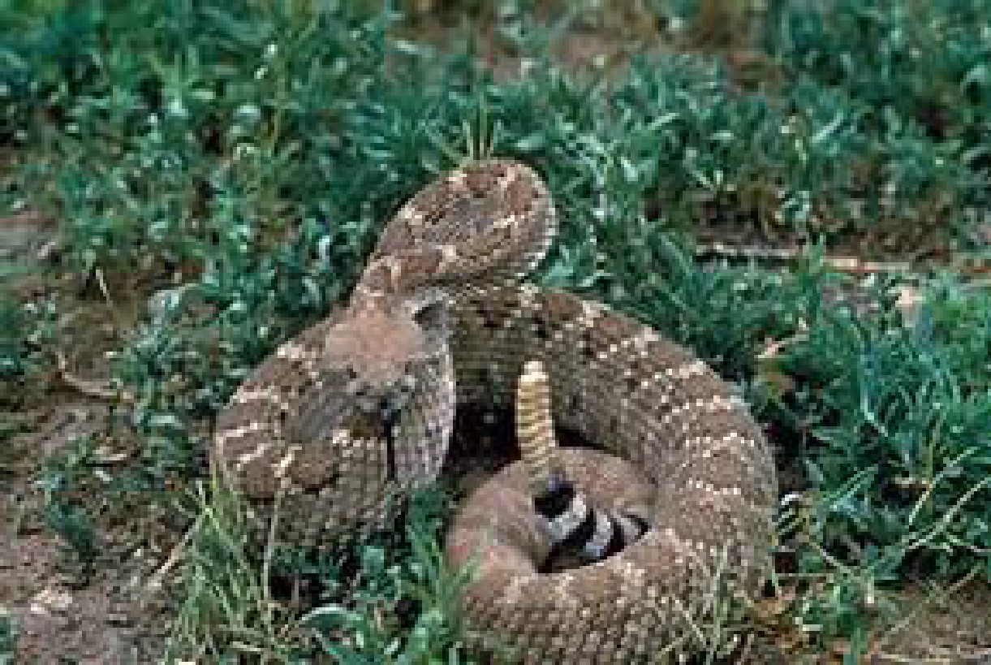
Please remember we live in rattlesnake country! It is highly unlikely that we run into a rattlesnake but be aware that we are in its habitat. Be Respectful. Keep scouts and other individuals clear of that area. Notify camp staff IMMEDIATELY! Without getting close to snake, try to keep an eye on snake until camp staff arrive.
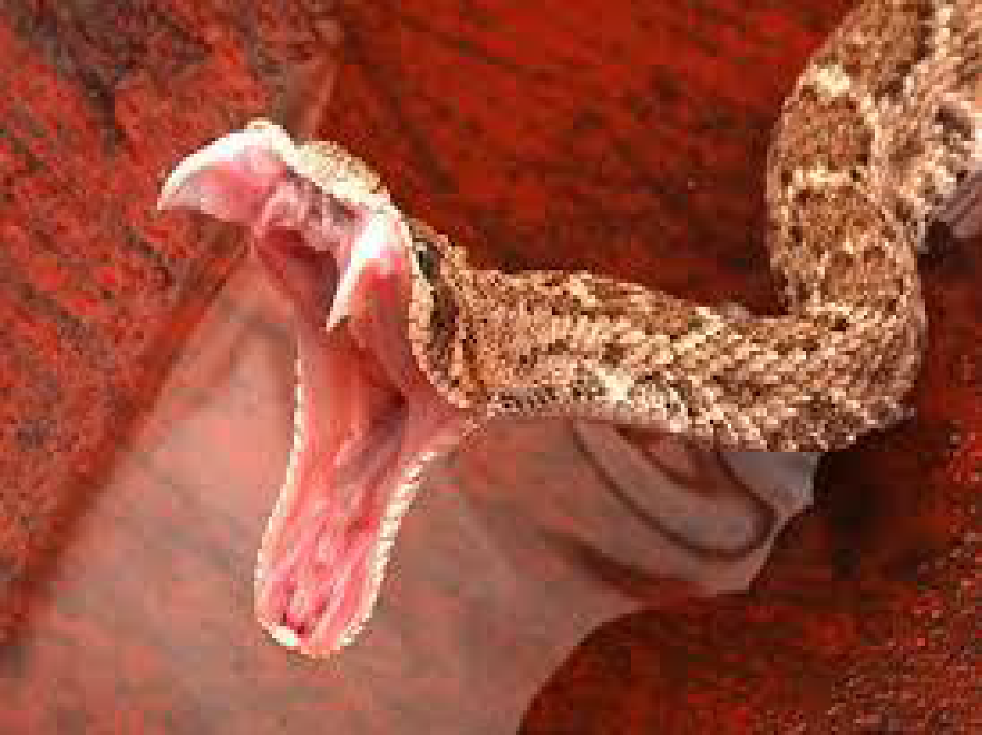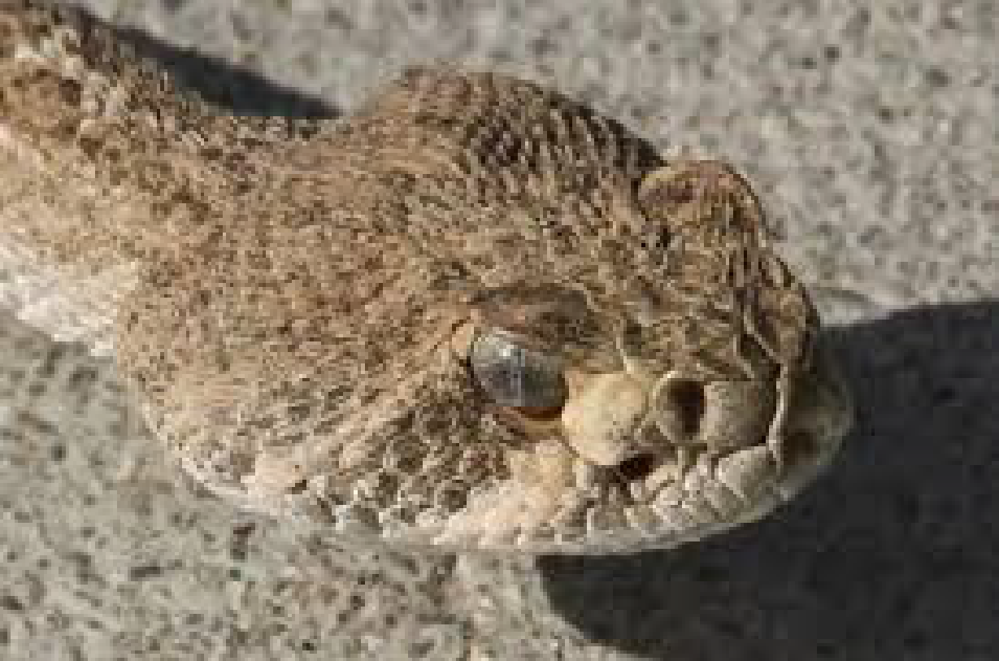
Notice the distinct shape of the head. Like an arrowhead.

Heat Exhaustion/Heat Stroke/ Sunburn:
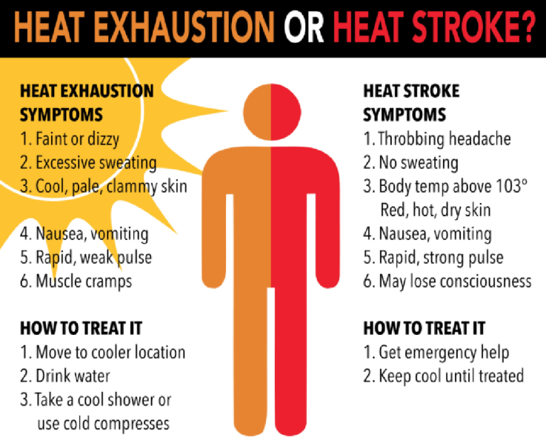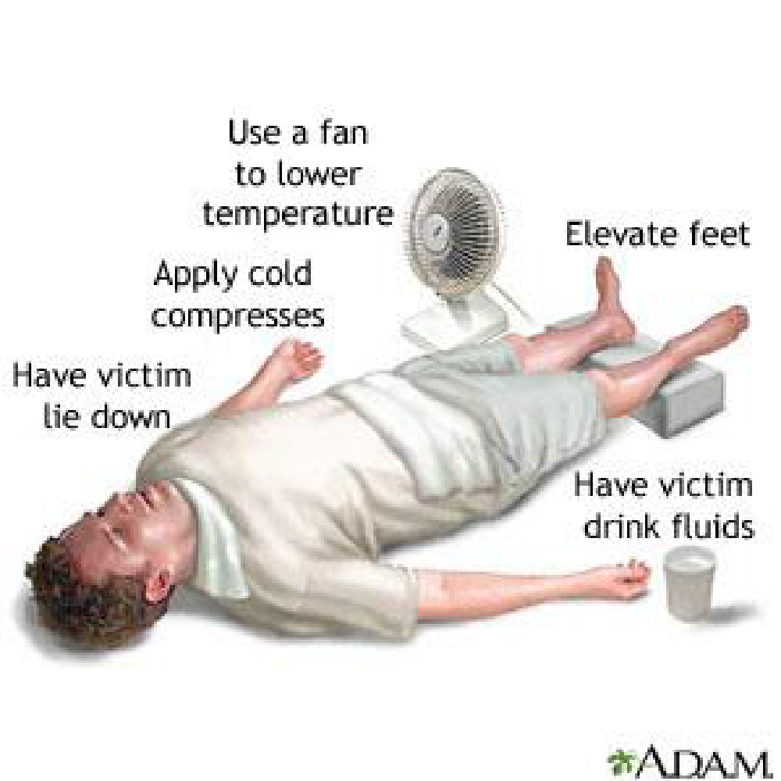
Please remember to drink plenty of water and stay hydrated. A hat is recommended. Troop neckerchiefs work great to soak and wrap around neck or cover head to stay cool. Apply and Reapply sunscreen. If any signs/symptoms occur notify first aid station and/or camp staff.

Allergies:
This is a camping event, so if you have allergies, please list them on your health form and make sure camp health officer is aware of them. Please be mindful of other individual’s allergies as well. Typical food allergies such as nuts, can be spread from the oils and “dust” of the nut as well.
PLEASE NOTIFY CAMP STAFF IMMEDIATELY OF ANY EMERGENCY

Water:
It is crucial that Scouts drink 2 liters of water per day. Water will not be available at the troop camp sites so please make sure that your patrols and units have the appropriate water containers to have enough drinking and cleaning water. Units/Troops will need to bring water igloos or containers for drinking and cooking water. Potable water is available at one place in camp.

Patrol & Troop Events (TBD)
There are a number of events for patrols and overall units at this Camporee. It is important that your entire unit and each individual patrol be as prepared as possible for each of the events. Each event is described below providing an objective, the methodology of scoring, and any materials that the patrol or unit should bring to the event. This is where the unit and patrol perform at its best in our district competition.

Check-In & Uniform Inspection:
Objective: Allows the unit to present itself to the camp, ensures required documents are on hand, and provides information & directions for unit camping.
Procedure: Check in will begin at 4 PM. All units on Friday will check in at Julie’s Joint. Webelos checking in on Saturday will check in at Julie’s Joint.
Documents required:
- A copy of your Troop & Patrol rosters with all attending members of the unit.
- Annual Health and Medical Record “Part A & B” for each Scout and Adult (these will be returned at check out)
Inspection: This will be judged as a patrol. Scoring based on the following:
- Uniform conformity is required at check in, flag ceremonies, and at the evening campfire.
  - Your standard Troop uniform is what you will be judged on. Scouts should check in wearing their Class-A uniforms which are to be worn at all assemblies and campfires. (i.e. if one scout is in shorts the whole troop should be, Scout socks, hat, etc.)
  - Class-B uniforms can be worn at all other times.
  - The Class-A uniform must be the outer garment and not covered with jackets, sweatshirts, etc.
- Scout spirit
  - Does your unit have a yell or song?
  - Did your unit exhibit an excited and organized eagerness to participate in camp?

Event List & Scoring
Each of the following events will be scored according to the event description. Please make sure to read the objective, materials, and scoring for each event. Awards will be given for the top three scores in each event by category.

Scoring and Time Limits
Each event will have a 20 minute time limit. We don’t want a patrol to bog down too long at any one event. With multiple events and skits there is plenty for a patrol to get through in one day. Please make sure your Scouts are prepared to keep moving throughout the day.
All events will have a primary score that could be based on time or successful completion of the challenge. In addition, each event will have points for Scout spirit, team work, patrol spirit, and use of the patrol method.
- Scout Spirit will be measured by watching the patrol to make sure they exhibit the best parts of the Scout Oath and Law.
- Team work will be measured by watching the patrol to see how they collaborate. Are they a bunch of individuals or a team? Do they help each other? Are they listening when appropriate? Do they work well together to complete the challenge?
- Patrol method will be measured based on the patrol leader’s capability of leading the patrol members. Does the patrol leader present the patrol to the event staff? Does the leader organize the patrol members? Does the leader make sure that all members are participating and know what their role is?
- Patrol spirit will be measured based on the patrol presenting itself to the event staff as one unit (no stragglers) with a patrol flag and a well-practiced patrol yell.

Events
- Archery
  - Objective: Each Scout will shoot five (5) arrows into a target from the same distance.
  - Description: Using BSA approved archery range and equipment Scouts will shoot 5 arrows into Bullseye targets.
  - Materials You Need To Bring:
    - None
  - Scoring:
    - Event Coordinators will add up the total number of hits (scores for each target ring) and then divide by the number of patrol members that shot.
    - Add up to 10 points for Patrol leader organization and patrol communication
    - Add up to 10 points for Scout spirit
    - Add up to 10 points for Patrol method
    - Add up to 10 points for Patrol spirit

We will update this and resend once we have more information.

Campfire Skit
Each patrol will get a chance to present a skit, run-on, or song at the evening campfire program. All performances must be approved by a camporee staff member.
Morale is critical at camp and campfire entertainment can help to give courage, discipline, and confidence.
BSA Ceremonies and Campfire Guidance
Ceremonies and campfires are fun and exciting parts of any camping experience! They give youth the ability to perform, but run-ons, stories, skits and songs must also fit within the program guidelines of the BSA. There are numerous things that are inappropriate and unacceptable. While the following is not an exhaustive list, it will help you begin the discussion about ensuring only appropriate material is portrayed:
• No name Calling, put-downs, Hazing
• No references to undergarments, nudity, or bodily functions
• No cross-gender impersonation at any point in the skit
• No derogatory references to or stereotyping of ethnic or cultural backgrounds, economic
situations, or disabilities
• No portrayal of sensitive social issues such as alcohol, drugs, gangs, guns, suicide, etc. – be mindful of this in song lyrics as well.
• Wasteful, ill-mannered, or improper use of food or water including wasting food in ANY way for comedic purpose is not allowed. You may not know the current situation of youth and adults who are in the audience. Many may not have adequate food at home and the wasting of food in any way would further point out this disparity. Additionally, there are parts of the world where water is not potable therefore the wasting of water is not appropriate.
• No inside jokes that exclude some of those present
• Do not change lyrics to patriotic songs (“America”, “America the Beautiful”, “God Bless
America”, “The Star-Spangled Banner”) or hymns and other spiritual songs
• Do not embarrass anyone – including staff or audience members (even if they are “in on it”) - just because the staff member is in on it, everyone in the audience is not aware of that fact and the appearance is that you are making fun of someone.
• Do not portray violent behavior or any behavior not in line with the Guide to Safe Scouting (ex. pointing “guns” at each other)
• No bathroom humor or skits/songs where a toilet is the punchline or a part of the skit or song.
• No water skits – NO ONE gets wet in any way (includes staff, and even if they are “in on it”)
• No material with sexual overtones
• Do not include anything that is not in keeping with the ideals of the Boy Scouts of America.
Best motto to have is: “If in doubt, take it out!”
All material should be vetted by the camp leadership team. Be sure you understand all aspects of the performance and what will happen. For example, a unit may have the same name for a skit and have a different interpretation of it than you expected.
Each of us has a role to help ensure our ceremonies and campfires represent the BSA ideals and brand.

Adult Dutch Oven Contest
- Objective: To cook the tastiest entry utilizing a Dutch oven.
- Description: To participate in this event, you will need to provide the ingredients for your entry, a Dutch oven, and coals to cook with. The ingredients are completely up to you and so is the type of entry!
- Participants will need to report to the check-in table to get a quick explanation of the competition and the rules.
- The OA will be picking up the entries and taking them to the judges.
- The entries will be numbered, and the judges will not know who presented the entry.
- Each entry will be turned in on time or earlier. There will be 15 points available for punctuality.
- Each entry must be cooked in a Dutch Oven(s) over coals or over a fire, at the Camporee.
- Each entry must be turned in with a typed recipe, and a complete ingredient list.
- Judging will be on three categories:
  - 20 points for presentation
  - 20 points for taste
  - 20 points for difficulty (Judges’ discretion)
  - We will average the point score of the judges and add the punctuality points for a total possible of 75 points.
Rules
  - Entrants must provide their own Dutch Oven
  - Cook it all in a Dutch Oven(s) over coals or over a fire, at the Camporee
  - You must provide your own raised metal surface to cook on, no scorched earth
  - You must properly dispose of all coals
  - Provide a typed recipe and complete ingredient list
  - HAVE FUN

2023 Camporee Campsite Inspections
Inspections will be conducted during event times on Saturday. This is scored as a single unit.

See attached campsite inspection scorecard.
Cuesta District - Spring Camporee 2023 Campsite Inspection Sheet
Troop# ______________
Campsite Setup & Patrol Method: [45 POINTS MAXIMUM]
• Tents lined up with clear patrol divisions (5) ________
• Tents pitched with proper use of ground cloth (5) ________
• Campsite is litter free (5) ________
• Troop flag posted at SPL tent - (5) ________
• Patrol Flags posted at PL’s tent when not @ event (5) _______
• Use of Leave No Trace Camping (20) ________
Subtotal: _________
Patrol Equipment: [25 POINTS MAXIMUM]
• Duty Roster & Menu posted (5) ________
• Cooking utensils & equipment clean (5) ________
• Dishwashing equipment clean & dry (5) ________
• First Aid kit available & posted (10) ________
Subtotal : ________
Safety & Sanitation: [40 POINTS MAXIMUM]
• Fire/water bucket full & posted (10) ________
• No Flames in Tents signs posted in each tent (5) ________
• Proper use of stoves/fuel storage (5) ________
• Food stored property & protected (5) ________
• Trash bags hung or stored neatly (5) Surrounding area clean ________
• Cleaning up after meals using 3-basins (LNT) (5) ________
• Grey water disposed of properly (5) ________
Subtotal: _________
Personal Equipment: [30 POINTS MAXIMUM]
• Inside and outside of Tent neat (10) _________
• Sleeping bags neat & dry (10) _________
• Clothes & gear stowed (10) _________
Subtotal: _________
Bonus
• Camp Gadget (30) _________
• US, CA & Troop flags posted (10) _________
Subtotal: _________
Final Points Score: __________
Comments:__________________________________________________
_________________________________________________________________________
_________________________________________________________________________

Camporee Schedule
(Tentative, times may vary on event day)
Friday, April 21st
4:00 – 6:00 PM: Arrival/Check-in and uniform inspection
6:00 – 7:00 PM: Set up camp
7:00 – 8:30 PM: Dinner
8:45 – 9:15 PM: Camporee Briefing (Scoutmasters & SPLs)
9:30 – 10:00 PM: Prepare for bed
10:00 PM: Light outs

Saturday, April 22nd
7:00 AM: Reveille
7:00 – 8:30 AM: Breakfast & Campsite clean-up
8:45 AM: Morning Flags and Announcements (OA Scouts to Lead)
9:00 AM – 12:00 PM: Events
12:00 – 1:30 PM: Lunch & Dutch oven check-in
1:30 - 4:00 PM: Events
4:00 – 6:00 PM: Free Time (4:30 PM: Dutch oven entries picked-up by OA)
5:00 PM: OA Member Ice Cream Social
6:00 – 7:30 PM: Dinner
7:45 – 9:15 PM: Closing Flags / Campfire, Performances & Awards Ceremony
9:15 - 9:30 PM: OA Call Out
9:30 – 10:00 PM: Free time
10:00 PM: Camp Quiet Time / Lights Out

Sunday, April 23rd
7:00 AM: Reveille
7:00 – 8:30 AM: Breakfast
8:45 AM: Flags / Camp Dismissed
9:00 – 11:00 AM: Break Camp / Campsite sign out (Campsite must be inspected by staff before check out)

GENERAL INFORMATION
1. LOCATION:
Larsen Meadow Campground
Forest Service Route 6N04
Santa Barbara, CA 93105
2. WHEN:
April 21-23, 2023
Check-in begins at 4:00 PM on Friday, April 21, 2023
Departure no later than 11:30 AM on Sunday, April 23rd
3. THEME:
“Wild West”
4. PROGRAM:
Come expecting some fun challenges. Scouts and Webelos will have the opportunity
to try their skills at various activities with the object of having fun.
5. FEES:
$25.00 per person for all youth & adult participants (Friday Dinner Included)
$10.00 per person if you want dinner on Saturday night (optional for adults only)
$15.00 per person for Saturday only participants with lunch & dinner included
$20.00 per Webelos/Parent (Dinner Included) Please plan to bring a sack lunch.
6. CHECK-IN:
On Friday all units will check-in at Julie’s Joint at Larsen Meadow.
We ask that you arrive together as a Unit (Den-Troop-Crew) if possible.
While the Guide to Safe Scouting prohibits caravanning, there is no reason your unit cannot form up as you arrive. Documents required: A copy of your rosters. An Annual Health and Medical Record “Part A & B” for every Scout and Adult (to be turned in and returned at check out).
On Saturday Webelos & late arrivals will check-in at Julie’s Joint - a check-in station will be set up near the trading post.
7. TROOP & PATROL EQUIPMENT:
Any troop or patrol equipment that is not carried in can be driven to the campsite, but the vehicle and/or trailer must be moved to the parking lot. Vehicles and trailers cannot stay in campsites.
8. WEBELOS:
Webelos Scouts May Not participate in overnight den camping. They will be required to leave after closing ceremonies after Campfire Saturday evening.
Webelos can only participate in BSA age appropriate activities/events.
9. CAMPSITES:
Campsites will be separated by gender (males separate from females). Each troop will be assigned a campsite. Troop volunteers must camp in the same campsite with their Scouts to provide adult supervision.
Campsite courtesy requires that you ask permission before entering another troop’s campsite.
10. PARKING:
Please Park in designated area ONLY – see Camp Map
11. ANNUAL HEALTH AND MEDICAL RECORDS:
Units must ensure that all participants (adults and youth) are medically able to participate in this event. Units should bring a copy of each participant’s health and medical record.
Frequently Asked Questions about the new form can be found at: https://www.scouting.org/health-and-safety/ahmr/
12. LEADERSHIP:
Two-deep adult leadership is required for each unit. NO EXCEPTIONS! Senior Patrol Leaders/Crew Presidents are responsible for their respective Troops /Crews.
13. BEHAVIOR:
As with any Scouting activity, a participant’s behavior will be in accordance with the Scout Oath, the Scout Law, and the Golden Rule. All adults are expected to follow the Scouter’s Code of Conduct.
14. UNIFORM: The uniform appropriate to one’s program (Venturing, Scout BSA, Cub Scout) should be worn during the Camporee. Activity uniforms (Class B scout or Scout-themed T-shirts) are appropriate except for check-in, assembly & flag ceremonies, campfires and religious services for which we request full Field Uniforms (Class A) be worn.
15. FIRST AID:
Units should handle all minor First Aid needs of their Scouts. There will be a Camporee First-Aid Station centrally located at Julie’s Joint for emergencies.
16. EMERGENCY PHONE:
A phone number has been established for emergencies only. Messages will be taken to the Camporee Chairperson and forwarded to the unit. Please make sure callers know to give unit number, contact person, and a detailed message when they call. The number is (805) 610-9674. This number is for EMERGENCIES ONLY!
Please understand that it may take some time to locate the message recipient.
17. TRASH:
Each unit is to bring their own garbage bags. All trash is to be properly bagged and placed in Unit camp trash can after each meal. Unit should bring a receptacle or have a place to store their trash during the evenings at the event. Units will be responsible for taking all their trash and trash bags back to their home stations. Pack it in pack it out and Leave No Trace. There is a lot of wildlife critters (raccoons, possums, skunks, etc.) who will be coming around looking for a meal.
18. CAMP SANITATION:
Dishes can be washed at the sink at Julie’s Joint. Food must be scraped into trash cans. No dishes are to be cleaned at water spigots. Gray water is to be properly disposed of.
19. LATRINES:
There will be Port-A-Potties available throughout all areas of camp for youth/Scouts. Port-A-Potties are single person use only.
20. ENVIRONMENTAL:
No digging of any kind will be allowed in the camping areas. Guide ropes and small stakes are acceptable, please use guide flags for safety.
21. FIRES:
The only fire allowed in the camp is at the Campfire ring. Camp stoves are allowed to cook with constant attendance.
22. CHECK OUT:
Units will be given their BSA medical forms after a campsite inspection by the Camporee Camp Staff
23. TRADING POST:
There will be a trading post available at Camporee. There will be snacks, drinks and accessories available for purchase. Don’t forget to bring a little extra spending cash to enjoy the full camporee experience!
24. WATER: Units/Troops will need to bring water igloos or containers for drinking and cooking water. Potable water is available in the camp.
25. ORDER OF THE ARROW: Scouts and Adults should plan on bringing and wearing their OA Sash. OA will be assisting in the events to collect scoring information, Dutch Oven cook-off, and helping with the Trading Post sales.

2023 Camporee Patrol Roster
Troop # ___________ Pack #_________
PATROL NAME: |  | New Patrol?  Y / N
Patrol Leader:
Scout Name: | Age | Rank
1.
2.
3.
4.
5.
6.
7.
8.
9.
10.

Who competes? Whenever possible competing patrols should be made up with your troop’s regularly organized patrols or Webelos dens. “Ringer” patrols made up for just the Camporee are not in keeping with good Scout Spirit.

Please note: Webelos may be restricted from participating in some events as posted in the guide to safe scouting.

