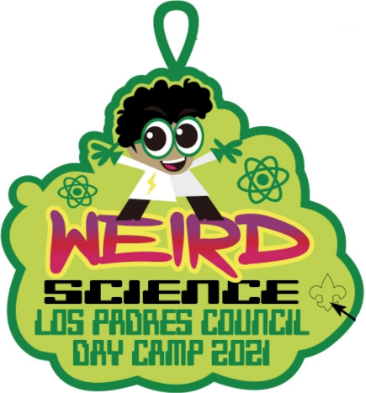
LIMITED TO 35 SCOUTS! GET YOUR REGISTRATIONS IN EARLY!
North Cuesta District Cub Scout Day Camp 2021

Monday, June 14 through Friday, June 18, 2021 9:00 am - 3:00 pm
Location: Paso Robles Scout House – 2247 Oak St. Paso Robles
One Range Day off-site in Atascadero - TBD

Regular price - $225.00 – ends on June 1
Late fee price -$250.00 – ends on June 10
Last day to register June 10
$40 discount for siblings
50% discount offered for 1 scout if parent volunteers for the whole week (must register before June 2nd)
$20/per day discount for partial week adult volunteers
Camperships are available; please contact your Camp Director for more info.

Scout’s name: ___________________________________________
Pack#____________ Nickname: _________________________
Grade** (fall 2021) __________ Age: __________ Birth Date: _______________________

**Den Determined by Fall 2021 Grade level: 1st 2nd 3rd 4th 5th

Address: ____________________________________________________________________
City: __________________________________ State _____________ Zip Code: _________

Parent Signature______________________________________ Date____________________

(By signing, you are stating that your child is registered with Cub Scouts. Should they not be, you are agreeing that the Pack has your permission to register them into their pack and you will agree to pay the pack the appropriate registration and unit fees.)

Parent / Guardian #1
Name: ______________________________ Email: __________________________________

Best Phone #1: _______________________ Best Phone #2: _____________________________

Parent / Guardian #2
Name: _____________________________ Email: __________________________________

Best Phone #1: ____________________ Best Phone #2: ____________________________

Circle T-Shirt size for youth: SM (6-8) MD (10-12) LG (14-16)

ADULT Sizes S MD LG XLG XXLG

Anything we need to know about your Cub Scout to provide them with the best possible camping experience?
_____________________________________________________________________________

_____________________________________________________________________________

_____________________________________________________________________________

Yes, I would like to help at Day Camp, please contact me.
I am available: All days____ Mon. _____ Tues. ___ Wed. ____ Thurs. ____ Fri. ____
Reduced registration fee available – Save $20 per day

Complete volunteer forms. (Adult Application)

Name: ___________________________________ Phone # ____________________________

E-mail: ______________________________________________________________________
Tot Lot is unavailable this year due to Covid -19 precautions.

Permission/ Waiver
S. 12552: Furnishing Firearms to Minors under 18 without permission of parent-- Every person who furnishes any firearm, air gun, or gas-operated gun, designed to fire a bullet, or metal projectile, to any minor under the age of 18 years, without an express or implied permission of the parent or legal guardian of the minor is guilty of a misdemeanor.
I give permission for ___________________________________________ to use a firearm as described above.

Signed: ___________________________________ Dated: ___________ Unit: _____________

Assumption of the Risk, Participant Statement
Relating to COVID-19 (CORONAVIRUS)
Your safety and the safety of all our members, volunteers, and employees is Los Padres Council’s top priority. While there is still much uncertainty regarding COVID 19, we are monitoring the information provided by health experts and government agencies to help keep safe those who choose to come to camp this summer.

First, staff and volunteers are coordinating with state and local health departments in San Luis Obispo and Santa Barbara Counties to ensure we are informed of and comply with their guidance to mitigate the risks COVID-19 being contracted at camp.

Our mitigation plan includes:
- Pre-attendance participant self-screening. If you become sick before or during camp; please do not attend camp and notify day camp director, Jeanne Gard at (805) 610-9674.
- Health screening upon your arrival at camp conducted by our camp health officers, which will also include a temperature check.
  - Note: should anyone not pass the arrival screening, the participant will not be allowed to enter camp.
- Limitations on visitors in camp.
  - All visitors will be screened upon arrival before entry to camp.
- There will be hygiene reminders while at camp.
- Extra handwashing /sanitizer stations throughout camp.
- Dedicated staff to clean and disinfect surfaces and shared program equipment.
- An emergency response plan that includes an isolation and quarantine protocol should a person at camp develop symptoms of COVID-19 or other communicable disease.
- Check-ins with each participant one week and two weeks after the camp to determine if any participants have developed symptoms.
- In accordance with BSA guidelines, there is to be no carpooling to and from camp
- Masks will be mandatory. You will be called to pick up your Scout if they do not wear their mask properly.

These precautions are important, but these efforts cannot eliminate the potential for exposure to COVID-19 or any other illness while at camp. Experts have said that people with COVID-19 may show no signs or symptoms of illness, but can still spread the virus, and people may be contagious before their symptoms occur. The fact is that someone with COVID-19 may pass the required health screenings and be allowed into camp.

We also know the very nature of camp makes social distancing difficult in many situations and impossible in others.

Information from the Centers for Disease Control and Prevention (CDC) states that older adults and people of any age who have serious underlying medical conditions are at higher risk for severe illness from COVID-19. If you are in this group, please ensure you have approval from your health care provider prior to attending camp.

Every staff member, volunteer, and Scouting family must evaluate their unique circumstances and make an informed decision before attending camp. We hope this information will be helpful as you make that choice.

*Please note that changes in state and county guidance at camp could change and we reserve the right to adjust our procedures accordingly.

For questions, contact:
Jeanne Gard 805-238-0175, daycamp19@gmail.com
Amanda Lamar 805-610-1551, daycamp19@gmail.com

Please provide this form along with the health and medical record form parts A & B and all other applicable forms with payment to:
Jeanne Gard
320 Melody Dr. Paso Robles, CA 93446

Please make checks out to: LPCBSA

